**07 –** **Tuple/Set**

**Ex. No: 7.1 Date: 18.05.24**

**Register No.: 2116231801113 Name: Murali Krishna M**

**Binary String**

Coders here is a simple task for you, Given string str. Your task is to check whether it is a binary string or not by using python set.

Examples:

Input: str = "01010101010"

Output: Yes

Input: str = "REC101"

Output: No

**For example:**

| **Input** | **Result** |
| --- | --- |
| 01010101010 | Yes |
| 010101 10101 | No |

**Program:**

a = input()

try:

c = int(a)

print("Yes")

except:

print("No")

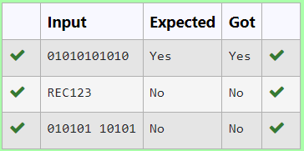

**Ex. No: 7.2 Date: 18.05.24**

**Register No.: 2116231801113 Name: Murali Krishna M**

**DNA Sequence**

The **DNA sequence** is composed of a series of nucleotides abbreviated as 'A', 'C', 'G', and 'T'.

For example, "ACGAATTCCG" is a **DNA sequence**.

When studying **DNA**, it is useful to identify repeated sequences within the DNA.

Given a string s that represents a **DNA sequence**, return all the **10-letter-long** sequences (substrings) that occur more than once in a DNA molecule. You may return the answer in **any order**.

**Example 1:**

**Input:** s = "AAAAACCCCCAAAAACCCCCCAAAAAGGGTTT"

**Output:** ["AAAAACCCCC","CCCCCAAAAA"]

**Example 2:**

**Input:** s = "AAAAAAAAAAAAA"

**Output:** ["AAAAAAAAAA"]

**For example:**

| **Input** | **Result** |
| --- | --- |
| AAAAACCCCCAAAAACCCCCCAAAAAGGGTTT | AAAAACCCCC  CCCCCAAAAA |

**Program:**

def findRepeatedSequences(s):

sequences = {}

result = []

for i in range(len(s) - 9):

seq = s[i:i+10]

sequences[seq] = sequences.get(seq, 0) + 1

if sequences[seq] == 2:

result.append(seq)

return result

s1 = input()

for i in findRepeatedSequences(s1):

print(i)

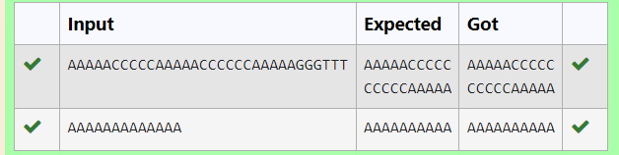

**Ex. No: 7.3 Date: 18.05.24**

**Register No.: 2116231801113 Name: Murali Krishna M**

**American keyboard**

Given an array of strings words, return *the words that can be typed using letters of the alphabet on only one row of American keyboard like the image below*.

In the **American keyboard**:

* the first row consists of the characters "qwertyuiop",
* the second row consists of the characters "asdfghjkl", and
* the third row consists of the characters "zxcvbnm".
* 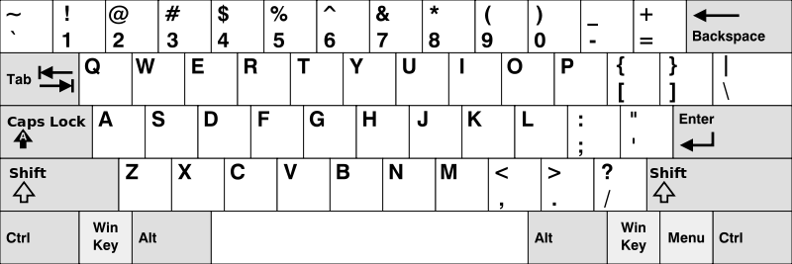
* **Example 1:**
* **Input:** words = ["Hello","Alaska","Dad","Peace"]
* **Output:** ["Alaska","Dad"]
* **Example 2:**
* **Input:** words = ["omk"]
* **Output:** []
* **Example 3:**
* **Input:** words = ["adsdf","sfd"]
* **Output:** ["adsdf","sfd"]
* **For example:**

| **Input** | **Result** |
| --- | --- |
| 4  Hello  Alaska  Dad  Peace | Alaska  Dad |

**Program:**

def findWords(words):

row1 = set('qwertyuiop')

row2 = set('asdfghjkl')

row3 = set('zxcvbnm')

result = []

for word in words:

w = set(word.lower())

if w.issubset(row1) or w.issubset(row2) or w.issubset(row3):

result.append(word)

if len(result) == 0:

print("No words")

else:

for i in result:

print(i)

a = int(input())

arr = [input() for i in range(a)]

findWords(arr)

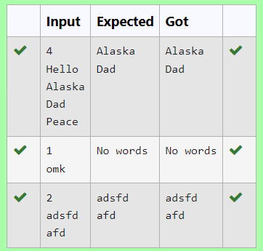

**Ex. No: 7.4 Date: 18.05.24**

**Register No.: 2116231801113 Name : Murali Krishna M**

**Print repeated no**

Given an array of integers nums containing n + 1 integers where each integer is in the range [1, n] inclusive.There is only **one repeated number** in nums, return this repeated number. Solve the problem using [set](http://118.185.187.137/moodle/mod/resource/view.php?id=734).

**Example 1:**

**Input:**nums = [1,3,4,2,2]

**Output:** 2

**Example 2:**

**Input:**nums = [3,1,3,4,2]

**Output:** 3

**For example:**

| **Input** | **Result** |
| --- | --- |
| 1 3 4 4 2 | 4 |

**Program:**

n =input().split(" ")

n = list(n)

for i in range(len(n)):

for j in range(i+1,len(n)):

if n[i] == n[j]:

print(n[i])

exit(0)

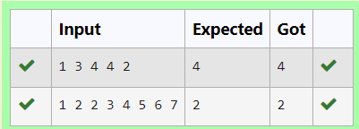

**Ex. No: 7.5 Date: 18.05.24**

**Register No.: 2116231801113 Name: Murali Krishna M**

**Check Pair**

Given a tuple and a positive integer k, the task is to find the count of distinct pairs in the tuple whose sum is equal to **K**.

**Examples:**

**Input**: t = (5, 6, 5, 7, 7, 8 ), K = 13   
**Output**: 2   
Explanation:   
Pairs with sum K( = 13) are  {(5, 8), (6, 7), (6, 7)}.   
Therefore, distinct pairs with sum K( = 13) are { (5, 8), (6, 7) }.   
Therefore, the required output is 2.

| Input | Result |
| --- | --- |
| 1,2,1,2,5  3 | 1 |
| 1,2  0 | 0 |

**For example:**

**Program:**

def count_distinct_pairs(t, K):

distinct_pairs = set()

for i in range(len(t)):

for j in range(i + 1, len(t)):

if t[i] + t[j] == K:

distinct_pairs.add((min(t[i], t[j]), max(t[i], t[j])))

return len(distinct_pairs)

t_input = input()

t = tuple(map(int, t_input.split(',')))

K = int(input())

print(count_distinct_pairs(t, K))

